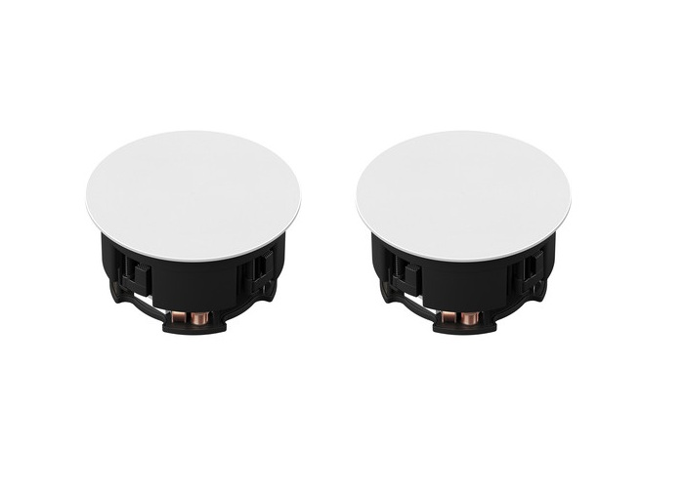

Brand:
Sonos
Model:
INCLGWW1

Weight in Kg:
2.2700

Color:
Black
Dimension

14.8 x 12.4 x 5.6"

