Brand:
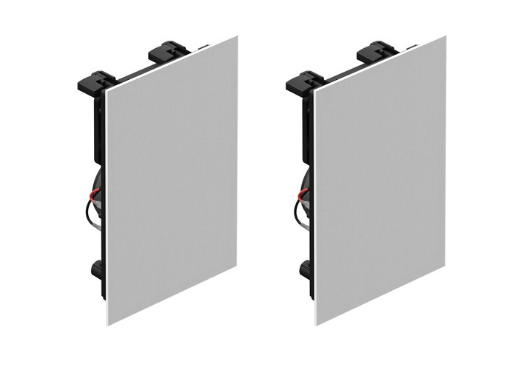
Sonos
Model:
INWLLWW1

Weight in Kg:

2.0900

Color:
Black
Dimension

15.1 x 11.3 x 9.8"

